**Towns in St. Lucia**

**Gros Islet**

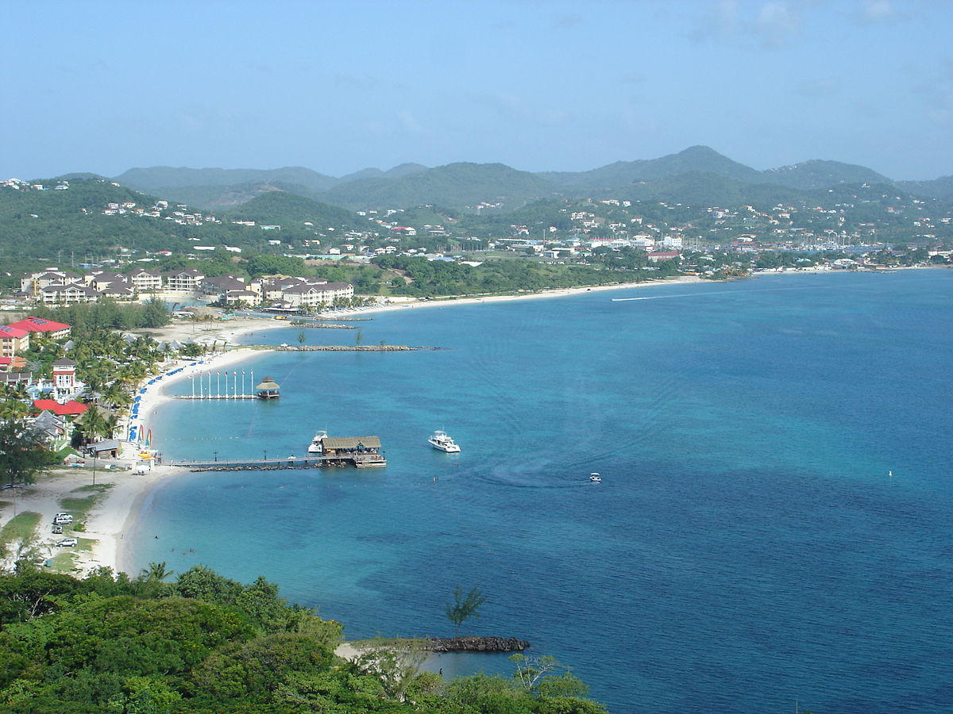

**Vieux Fort**

